Lab # 04
Conditional Execution

- Conditional Execution
Conditional executions such as ‘for loops’ and ‘if-else’ in C, are accomplished in assembly using conditional and unconditional jump statements. Jump statements break the normal sequence of execution and code starts executing from the jump address instead of the next instruction. PC stands for ‘program counter’, which hold the address for the next instruction. means if the condition is true, PC will be filled with address of the instruction after ‘label’, instead of the next instruction in sequence.
- Conditional Branches

beq register1, register2, L1
This instruction means go to the statement labeled L1 if the value in register1
equals the value in register2. The mnemonic beq stands for branch if equal.

bne register1, register2, L1
It means go to the statement labeled L1 if the value in register1 does not equal
the value in register2. The mnemonic bne stands for branch if not equal. These
two instructions are traditionally called conditional branches.

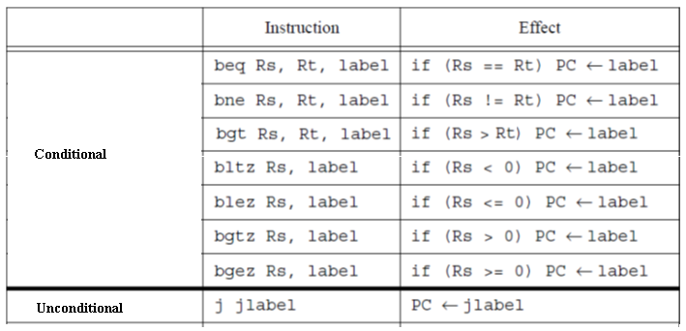
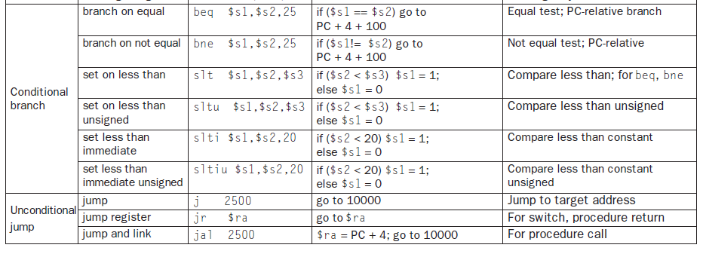
- Jump and Link and Jump Register Instructions:
As in high level languages, when programming in assembly language you should split up your program into smaller functions, that you can reuse. One of the key ideas with functions is that you can call them from anywhere and return back to where you called the function from. The MIPS processor has two instructions that enable you to call functions, jr and jal.

Jump and link:
jal label
Copies the address of the next instruction into the register $ra (register 31) and then jumps to the address label.

Jump Register:
jr $register jumps to the address in $register most common use jr $ra.
Example:
.text
.globl main

main:
jal message # Call message function
jal message # Call again

li $v0, 10 # Exit program
syscall

message:
li $a0, 100 # Load integer 100
li $v0, 1 # Print integer syscall
syscall
jr $ra # Return to caller

- Loops
Loops are implemented using conditional branch statements, or, with the combination of conditional and unconditional branch statements.
Example: (Conditional branches)
main: # A loop that iterates 500 times.
li $t1,0
li $t2,0 # i
li $t3,500 # j

Loop:
addi $t2,$t2,1 # i=i+1
addi $t1,$t1,1
bne $t2,$t3,Loop # i != j jump to Loop
li $v0,10
syscall
main:
li $t1,0
li $t2,0
li $t3,500

Loop:
addi $t2,$t2,1
addi $t1,$t1,1
beq $t2,$t3,Exit # i == j jump to exit
j Loop

Exit:
li $v0,10
syscall

- Branching (If-else)
Branching is implemented using combination of conditional and unconditional jump instructions.
Example: (Conditional branches & Unconditional Jumps)
.text
.globl main

main:
li $t1, 0 # t1 = 0
li $t2, 1 # t2 = 1
li $t3, 0 # t3 = 0

bne $t2, $t3, ELSE # If t2 != t3, jump to ELSE (t1 += 2)

IF:
addi $t1, $t1, 1 # t1 += 1
j Exit # Jump to Exit to skip ELSE

ELSE:
addi $t1, $t1, 2 # t1 += 2

Exit:
li $v0, 10 # Exit syscall
syscall

6: Conditional Jump Instructions in Assembly:
Conditional jump instructions control program flow based on flags in the status register. These are often used in decision-making and looping.
Common Conditional Jump Instructions:
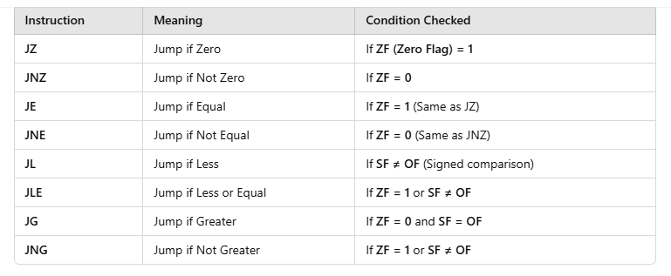
LOOP INSTRUCTIONS:
For loop:
.data
newline: .asciiz "\n" # String for a newline
.text
.globl main
main:
li $t0, 1 # i = 1 (loop variable)
li $t1, 5 # Upper limit (5)
for_loop:
bgt $t0, $t1, exit # If i > 5, exit loop
# Print the current value of i
move $a0, $t0 # Load i into $a0 for printing
li $v0, 1 # Print integer syscall
syscall

# Print newline
li $v0, 4
la $a0, newline
syscall

# Increment i
addi $t0, $t0, 1 # i = i + 1
j for_loop # Jump back to start of loop

exit:
li $v0, 10 # Exit program
syscall

7.While
Example:
.data
newline: .asciiz "\n" # String for a newline
.text
.globl main
main:
li $t0, 1 # i = 1 (loop variable)
li $t1, 5 # Upper limit (5)

while_loop:
bgt $t0, $t1, exit # If i > 5, exit loop

# Print the current value of i
move $a0, $t0 # Load i into $a0 for printing
li $v0, 1 # Print integer syscall
syscall

# Print newline
li $v0, 4
la $a0, newline
syscall

# Increment i
addi $t0, $t0, 1 # i = i + 1
j while_loop # Jump back to start of loop

exit:
li $v0, 10 # Exit program
syscall

8.Do while
.data
newline: .asciiz "\n" # String for a newline

.text
.globl main

main:
li $t0, 1 # i = 1 (loop variable)
li $t1, 5 # Upper limit (5)

do_while_loop:
# Print the current value of i
move $a0, $t0 # Load i into $a0 for printing
li $v0, 1 # Print integer syscall
syscall

# Print newline
li $v0, 4
la $a0, newline
syscall

# Increment i
addi $t0, $t0, 1 # i = i + 1

# Loop condition: while (i <= 5)
ble $t0, $t1, do_while_loop # If i <= 5, repeat loop

exit:
li $v0, 10 # Exit program
syscall

Lab Task:
Write a program that takes input of an integer from the user and computes its Factorial.?

